Ex. No.: 8
Date:

AIM:

Query with Sub Query& Correlated Query

To perform Sub Query and Correlated Query on the Employee and Department tables.

DESCRIPTION:
SUBQUERY
A MySQL subquery is a query nested within another query such as SELECT, INSERT, UPDATE or DELETE. In addition, a MySQL subquery can be nested inside another subquery.

A MySQL subquery is called an inner query while the query that contains the subquery is called an outer query. A subquery can be used anywhere that expression is used and must be closed in parentheses.

CORRELATED QUERY:

A correlated subquery is a subquery that uses the data from the outer query. In other words, a correlated subquery depends on the outer query. A correlated subquery is evaluated once for each row in the outer query.

SYNTAX:

SUBQUERY:

SELECTc1, c2,...,cn
FROMtable
WHEREc1 IN (SELECTc1, c2,...,cn
FROMtable WHEREwhere_conditions);

CORRELATED QUERY:

SELECT*
FROMtable_name WHEREEXISTS (subquery );

Questions:

Sub-Query and Correlated Sub-Query:
1. Display the employees whose Employee ID is greater than the average Employee ID.
2. Display the employees who belong to the same department as Suresh R.

3. Display the employee having the highest Employee ID.

4. Display the employees whose Employee ID is greater than the average Employee ID of their department. (Correlated Query)

OUTPUTS:

1)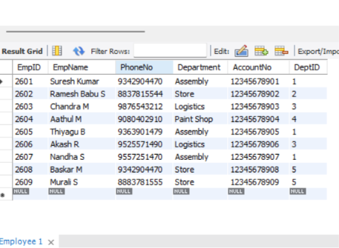

2)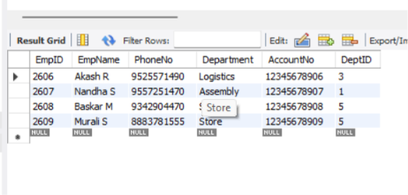

3)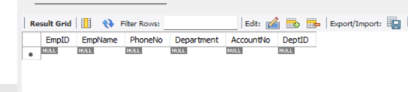

4)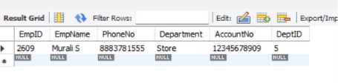

5)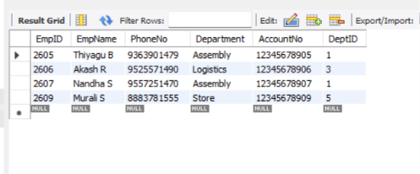

RESULT:

The records from the tables are displayed using Sub-Query and Correlated Sub-Query.

